**Project Two: Summary and Reflections Report**

This project has given me insight into many new concepts and potential coding solutions. This report will summarize my approach to unit testing, experiences writing JUnit tests, and overall reflections on the mobile application development project. It details the testing strategies employed, the quality of the implemented tests, and the mindset adopted throughout the development process.

For each feature, I implemented a comprehensive unit testing strategy using JUnit. This involved creating a combination of positive and negative test cases to verify the functionality as outlined in the software requirements document. The test cases covered various scenarios, including edge cases like empty strings, invalid inputs, and handling of different time zones. Each test case is directly mapped to a specific requirement, ensuring thorough coverage of all functionalities. I was able to receive an overall 92.6 percent in JUnit coverage, which was an optimal percentage. 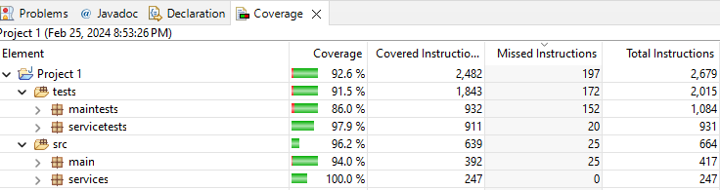

The JUnit tests demonstrate high quality through several factors. Firstly, they achieve a high coverage percentage, indicating extensive testing of the codebase. Secondly, meaningful test names enhance readability and maintainability. Finally, the tests incorporate edge cases and invalid inputs to ensure the code's robustness.

While writing the JUnit tests, I prioritized adhering to best practices for code formatting and commenting. I also focused on efficiency by avoiding unnecessary setup and teardown logic and utilizing data-driven testing techniques for repetitive scenarios.

The project primarily relied on unit testing to verify individual units of code in isolation. Additionally, black-box testing was employed to assess the application's functionality from an external user's perspective. While white-box testing was used to some extent for understanding the code's internal logic, techniques like integration testing and performance testing were not applicable due to the project's scope.

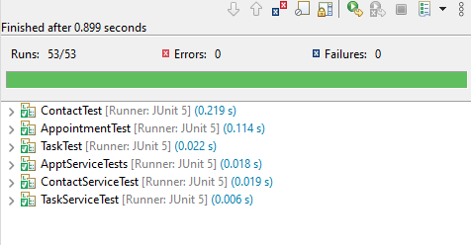

Throughout the development process, I adopted a cautious mindset, carefully considering various scenarios and edge cases to ensure comprehensive testing. Appreciating the code's complexity and potential interactions between functionalities was crucial for designing tests that exercised various combinations of features.

To mitigate potential biases in code review, I conducted thorough reviews focusing solely on functionality and logic. Furthermore, I employed test-driven development in some aspects, where writing tests first defined the expected behavior, guiding the implementation to meet those expectations.

Bias can be a significant concern when developers test their code. Familiarity with the code can lead to overlooking potential issues, and confirmation bias can cause developers to subconsciously focus on confirming their assumptions rather than identifying potential problems.

Maintaining discipline in software development is crucial to avoid technical frustration. This involves not cutting corners during the testing process and ensuring thorough coverage to prevent future issues. By prioritizing quality and adhering to best practices developers can contribute to a more robust and maintainable codebase.

In conclusion, my experience with JUnit testing in this project has equipped me with valuable skills and solidified its importance in my future development endeavors. The ability to write clear, concise, and effective unit tests not only ensures code quality and adherence to requirements but also fosters a disciplined and cautious approach to software development. As I progress in my career, I will continue to leverage JUnit and explore other testing techniques to deliver robust, reliable, and maintainable software solutions.